Big Headline
Minor headline.
Minor headline
Minor headline
NEWSPAPER TITLE
May 31, 2063
Your Paper Name
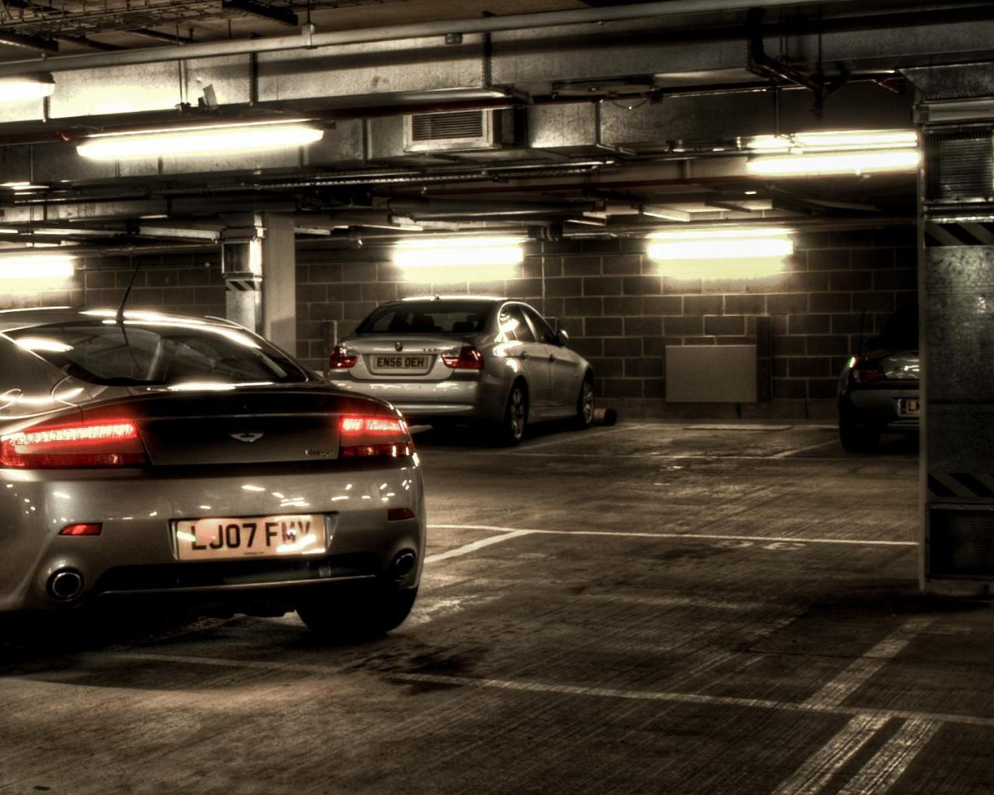
Replace with pic or graph
Caption for pic/graph
Replace with Article Title For Geosphere
Your text can go here. Your text can go here. Your text can go here. Your text can go here. Your text can go here. Your text can go here. Your text can go here. Your text can go here. Your text can go here.
Replace with Article Title For Hydrosphere
Your text can go here. Your text can go here. Your text can go here. Your text can go here. Your text can go here. Your text can go here. Your text can go here. Your text can go here. Your text can go here.
Replace with pic or graph
Caption for pic/graph
Replace with Article Title For Biosphere
Your text can go here. Your text can go here. Your text can go here. Your text can go here. Your text can go here. Your text can go here. Your text can go here. Your text can go here. Your text can go here.
Replace with Article Title For Atmosphere
Your text can go here. Your text can go here. Your text can go here. Your text can go here. Your text can go here. Your text can go here. Your text can go here. Your text can go here. Your text can go here.
Replace with Title for Summary Article
Your text can go here. Your text can go here. Your text can go here. Your text can go here. Your text can go here. Your text can go here. Your text can go here. Your text can go here. Your text can go here.
Replace with pic or graph
Caption for pic/graph
Replace with pic or graph
Caption for pic/graph
Replace with pic or graph
Caption for pic/graph

