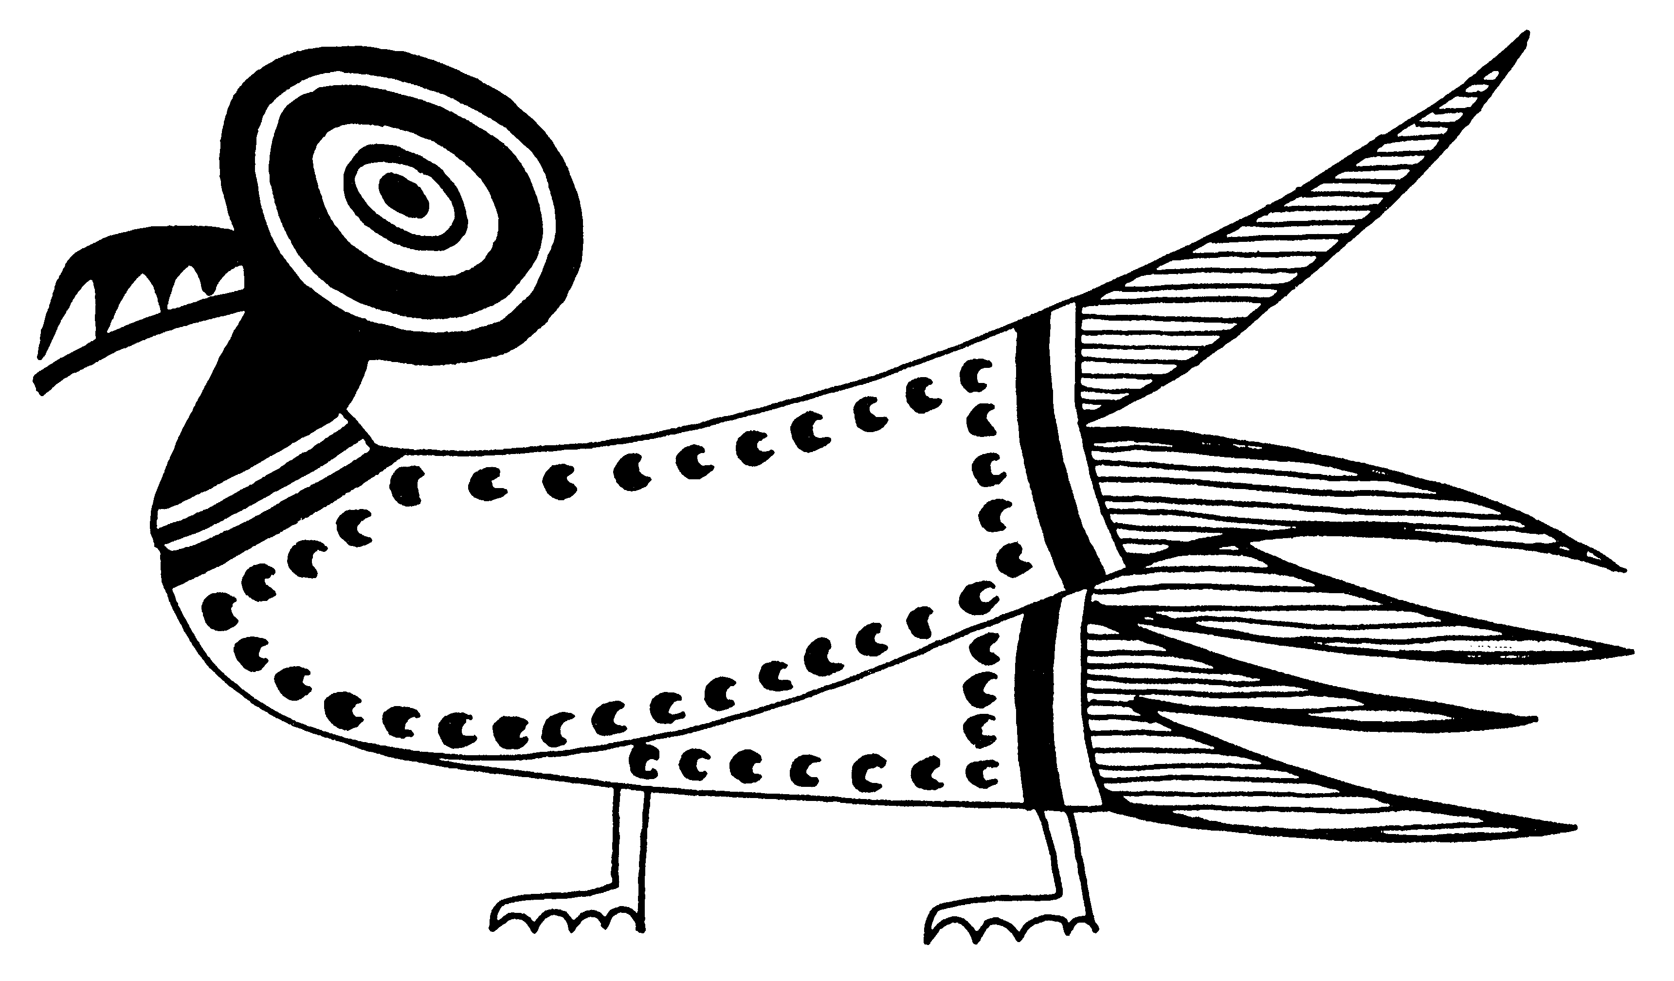 Name__________________ Date___________________
Pd.____________________ Ms. Hay World Studies

Modern African Nation States Internet Research Project

Enduring Understanding: Today the nations of the African Continent strive to develop economic, political, and social systems that promote stability and economic growth.

Objective: To analyze the evolution and development of Modern African Nations from the period of European colonization to economic independence in the 20th and 21st centuries. To identify major geographical, political, social, economic and cultural characteristics of one of the nations of Africa and to compare this culture with the culture of the United States. Each team will also identify and choose a historical figure from the same county.
African Nations:
North Africa Region:
Egypt Algeria Morocco Libya

Western Africa Region:
Tunisia Algeria Sierra Leone Cameroon
Morocco Liberia Western Sahara Cote d’Ivoire
Guinea Nigeria Burkina Faso Mauritania
Ghana Senegal Togo Gambia
Benin Niger Guinea-Bissau Mali

Eastern Africa Region:
Egypt Eritrea Djibouti
Chad Ethiopia Sudan Somalia

Central African Region:
Central African Republic Burundi Comoros
Cameroon Zambia Gabon
Congo Republic Uganda Angola
Kenya Namibia Tanzania
South Africa Congo Malawi
Equatorial Guinea

Southern African Region:
Angola Zambia Mozambique
Lesotho Botswana Rwanda
Swaziland Namibia South Africa
Zimbabwe Madagascar

Historical Figure: Writers, Religious Leaders, Human Rights Leaders, Political and Government Leaders, World Leaders, Sports Figures, Musicians and Artists are a few of the categories to research in order to find past and present historically significant people from your region of study. {Ms. Hay must approve the selection}

Each team will consist of two students, which will be assigned a nation; you may choose the historical figure.

Requirements:

1) All information, statistics and facts are to be gathered using internet research techniques learned in class.

2) Each Team will create a poster that includes; a hand drawn map of their country, showing the capital, major cities, physical features and major landmarks, and natural resources. This map should be large enough for the entire class to see during your presentation. The flag of your county is to be included on the poster containing your map.

3) Each team will create a power point presentation describing your African Nation. You will have scheduled time in the WOMS media center for research and creating your power point. You may want to make arrangements to meet in the media center after school to polish and complete your work. It will require time outside of the classroom to complete your project.

4) You will be comparing your Nation with the United States. Your team will compare the GDP, life expectancies of men and women, literacy rate, lifestyle and educational level. You must create graphs or pie charts to show these comparisons.

5) You will present a biography of a famous person from this part of the world. Using the web you should be able to find images, music or any other examples of the life work of this famous person, anything that will enhance your presentation and bring your historical figure to life.

6) You are required to include a bibliography of not less than five web sites listed in alphabetical order. See attached examples of the proper notation for a bibliography.

7) **** OPTIONAL ***** Bring to class any items that may be from your country. This may include, but not limited to, regional clothing, national dolls, and musical instruments. Unfortunately due to county policy, regional food must be limited to prepackaged items and may not be homemade. Please feel free to bring in videotape or pictures if you or anyone you know has traveled to your chosen area. Please let me know if you are having trouble finding cultural artifacts.

Grade: Your grade will be based upon the following rubric.

CATEGORY | 100-90 % | 89-80 % | 79-70 % | <69%
Amount of Information | All topics are addressed and all questions answered with at least 2 sentences about each. | All topics are addressed and most questions answered with at least 2 sentences about each. | All topics are addressed, and most questions answered with 1 sentence about each. | One or more topics were not addressed.
Quality of Information | Information clearly relates to the main topic. It includes several supporting details and/or examples. | Information clearly relates to the main topic. It provides 1-2 supporting details and/or examples. | Information clearly relates to the main topic. No details and/or examples are given. | Information has little or nothing to do with the main topic.
Internet Use | Successfully uses suggested internet links to find information and navigates within these sites easily without assistance. | Usually able to use suggested internet links to find information and navigates within these sites easily without assistance. | Occasionally able to use suggested internet links to find information and navigates within these sites easily without assistance. | Needs assistance or supervision to use suggested internet links and/or to navigate within these sites.
Diagrams & Illustrations | Diagrams and illustrations are neat, accurate and add to the reader's understanding of the topic. | Diagrams and illustrations are accurate and add to the reader's understanding of the topic. | Diagrams and illustrations are neat and accurate and sometimes add to the reader's understanding of the topic. | Diagrams and illustrations are not accurate OR do not add to the reader's understanding of the topic.
Sources | All sources (information and graphics) are accurately documented in the desired format. | All sources (information and graphics) are accurately documented, but a few are not in the desired format. | All sources (information and graphics) are accurately documented, but many are not in the desired format. | Some sources are not accurately documented.

1) Under no circumstances will students be allowed to read from a computer
printout. Nor will you be able to “cut & paste” information from a website. This would constitute plagiarism; you must rephrase the information into your own words and cite the web address in your bibliography.

2) Using the Notes option of power point presentation each team will hand in a copy of the presentation notes.

- Each presentation should last at least five minutes. Five minutes is the minimum; your presentation may take longer but not more than fifteen minutes. Remember this is a 200-point project and carries the weight of two summative assessments, one for research and one for presentation.

Information Rubric: (include all information for a successful Presentation)
I. Geography: (map poster with notes)
Population/ population density
Climate
Surrounding countries and/or bodies of water
Physical features
Natural resources
Capital and other major cities
II. Government:
Type of government
Name of present leader
III. History:
Possible independence dates from a colonial power.
Any major event from the last 5 years, that has made worldwide news. (Natural disasters, major conflicts, new discoveries...)
IV. Economy:
Currency and rate of exchange against the U.S. dollar
Imports (Why are these products brought into the country?)
Exports (How are these products used by other countries?)
Agricultural products (how are they used?)
Major trading partners
Jobs
Successes/ Problems
V. Culture:
Ethnic groups (% of population)
Languages spoken
Major religions observed
Types of food / Traditional foods
The Arts: Music, Dance, Theater, Literature etc.
Interesting/unusual customs
Famous attractions
Sports and leisure activities
National Holidays

VI. Comparison with the United States:
The GDP (Gross Domestic Product) per capita ~ this is the average annual income for the citizens of the country you are researching.
Life expectancy rates (male & female)
Literacy rate
Average level of education
VII. Historical Figure:
Birth and Death dates
Short life history -
What is it that makes this person historically significant?

Directions:
- Today will be used chose your partner and topic country. If you have a heritage from an African Nation you will be given the first chance to choose this nation. Partners will be matched using a random method; each team will divide the responsibility of topics, and hand in a list of topics.

- You will have several class periods in the computer lab to research your topics. If you do not finish your research, your team will have to return on your own time to complete your project. You may want to investigate the public library as a possible resource.

- Have your teacher check your notes.

- After your lab time and before your presentation you must complete your research, prepare your presentation and practice giving your presentation to an audience.

- The Presentations will begin the week of January 18th .NO adjustments will be made in the event of snow days, unless our dates in the media center are affected. Each team must be ready by this date, you may be called first! All posters must be brought to class on Tuesday 1/19/10. Remember each presentation must be at least 5 minutes long but no longer than 15 minutes.

Important Dates
1/8/10 – Chose Country & divide areas of responsibilities
1/11/10 – Start week long research in Media Center
1/12/10 - Progress/ Note check
1/14/10 – Note Check
1/19/10 – Posters and projects due to on line“Hand in Folder”

- This project will create several grades:
Content (50pts.) ~ Summative
Oral presentation (50pts.) ~ Formative
Note checks (20pts) ~ Class work
Content Rubric
a) Completeness and accuracy of information
b) Organization and clarity: how well you know your subject and how easy is it to understand.
c) Creativity
d) At least 3 comparisons to the United States
e) Bibliography

Oral Presentation Rubric
a) Use of sentences that are short and easy to understand
b) Look at your audience when you speak
c) Speak loudly, clearly and slowly
d) Use of gestures to make your point while speaking
e) Use of pictures, visuals or props.

Web Sites to Get You Started:

Web Address Link Information

www.cia.gov search National Statistics and basic facts

www.plcmc.org site index/Maps & Flags Maps & Flags of African Nations

www.google.com country name various web sites, read abstracts

www.nmafa.si.edu/pubaccess/index.htm National Museum of African Art

www.africaresource.com Current events & Regional News

www.Africannews.com Up to date news about the Continent

Bibliographic Format:

Internet Bibliographies must include the Title of the Webpage, Web Address, Date of Information and if possible name of Webmaster. Add the websites to your bibliography as you use them. The following are few examples:
Africa South of the Sahara
www-sul.stanford.edu/depts/ssrg/africa/current.html

African Studies Center, University of Pennsylvania
www.africa.upenn.edu/asc/ascevents.html - 33k -
Feb 6, 2004 –

Africa Daily
www.africadaily.com/ - 87k –

Website / Online Database Bibliographic Information

Author (if given) ______________________________________________________________
Title of Site__________________________________________________________________
Title of the Article or section of website___________________________________________
Organization sponsoring the site/ Publisher (if given) ______________________________
____________________________________________________________________________
Copyright date (online databases only) ___________________________________________
Retrieved on (Month /Day/ Year) ______________________________________________
Retrieved From (URL Address) http:// __________________________________________
____________________________________________________________________________

Author (if given) ______________________________________________________________
Title of Site__________________________________________________________________
Title of the Article or section of website___________________________________________
Organization sponsoring the site/ Publisher (if given) ______________________________
____________________________________________________________________________
Copyright date (online databases only) ___________________________________________
Retrieved on (Month /Day/ Year) ______________________________________________
Retrieved From (URL Address) http:// __________________________________________
____________________________________________________________________________

Author (if given) ______________________________________________________________
Title of Site__________________________________________________________________
Title of the Article or section of website___________________________________________
Organization sponsoring the site/ Publisher (if given) ______________________________
____________________________________________________________________________
Copyright date (online databases only) ___________________________________________
Retrieved on (Month /Day/ Year) ______________________________________________
Retrieved From (URL Address) http:// __________________________________________
____________________________________________________________________________

Author (if given) ______________________________________________________________
Title of Site__________________________________________________________________
Title of the Article or section of website___________________________________________
Organization sponsoring the site/ Publisher (if given) ______________________________
____________________________________________________________________________
Copyright date (online databases only) ___________________________________________
Retrieved on (Month /Day/ Year) ______________________________________________
Retrieved From (URL Address) http:// __________________________________________
____________________________________________________________________________

Author (if given) ______________________________________________________________
Title of Site__________________________________________________________________
Title of the Article or section of website___________________________________________
Organization sponsoring the site/ Publisher (if given) ______________________________
____________________________________________________________________________
Copyright date (online databases only) ___________________________________________
Retrieved on (Month /Day/ Year) ______________________________________________
Retrieved From (URL Address) http:// __________________________________________
____________________________________________________________________________

Author (if given) ______________________________________________________________
Title of Site__________________________________________________________________
Title of the Article or section of website___________________________________________
Organization sponsoring the site/ Publisher (if given) ______________________________
____________________________________________________________________________
Copyright date (online databases only) ___________________________________________
Retrieved on (Month /Day/ Year) ______________________________________________
Retrieved From (URL Address) http:// __________________________________________
____________________________________________________________________________

Author (if given) ______________________________________________________________
Title of Site__________________________________________________________________
Title of the Article or section of website___________________________________________
Organization sponsoring the site/ Publisher (if given) ______________________________
____________________________________________________________________________
Copyright date (online databases only) ___________________________________________
Retrieved on (Month /Day/ Year) ______________________________________________
Retrieved From (URL Address) http:// __________________________________________
____________________________________________________________________________

Author (if given) ______________________________________________________________
Title of Site__________________________________________________________________
Title of the Article or section of website___________________________________________
Organization sponsoring the site/ Publisher (if given) ______________________________
____________________________________________________________________________
Copyright date (online databases only) ___________________________________________
Retrieved on (Month /Day/ Year) ______________________________________________
Retrieved From (URL Address) http:// __________________________________________
____________________________________________________________________________
Modern African Nation States Internet Research Project

Vocabulary

1. Population Density: ____________________________________________________________________________________________________________________________________________________________________________________________________________________________________________________________________________________________________________________

2. Natural Resources:
____________________________________________________________________________________________________________________________________________________________________________________________________________________________________________________________________________________________________________________

3. Colonial Power:
____________________________________________________________________________________________________________________________________________________________________________________________________________________________________________________________________________________________________________________

4. Currency:
____________________________________________________________________________________________________________________________________________________________________________________________________________________________________________________________________________________________________________________

5. Rate of Exchange:
____________________________________________________________________________________________________________________________________________________________________________________________________________________________________________________________________________________________________________________

6. Imports:
____________________________________________________________________________________________________________________________________________________________________________________________________________________________________________________________________________________________________________________

- Exports:
____________________________________________________________________________________________________________________________________________________________________________________________________________________________________________________________________________________________________________________

- Gross Domestic Product ( GDP)
____________________________________________________________________________________________________________________________________________________________________________________________________________________________________________________________________________________________________________________

- Life Expectancy:
____________________________________________________________________________________________________________________________________________________________________________________________________________________________________________________________________________________________________________________

10. Literacy Rate: ____________________________________________________________________________________________________________________________________________________________________________________________________________________________________________________________________________________________________________________

