Locker Combination Opening

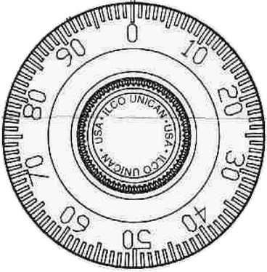
Turn the dial at least one full turn to clear it.

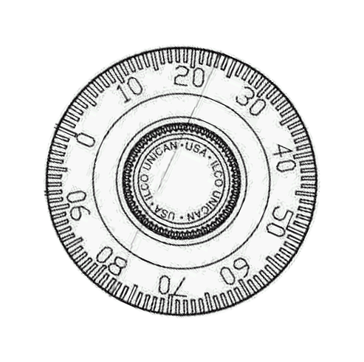Go right to your 1st number

______________
Go left. Pass your 2nd number and keep going left until
you reach your second number again.

______________
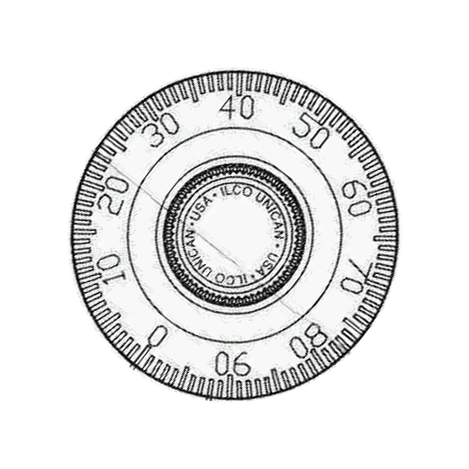
Go right to your 3rd number and continue to turn slowly
past it and pull the knob at the same time.

_______________

