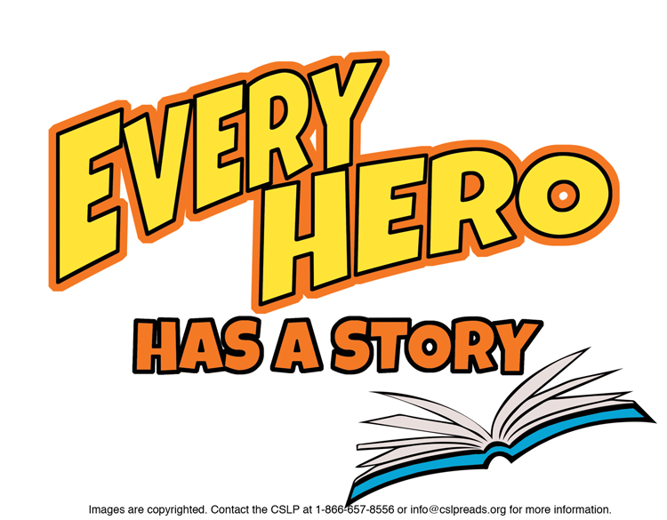

**Suggestions for Kindergarten**

**PICTURE BOOKS**

Breen, Steve. ***Violet the Pilot.***A young aeronautic genius.

Catusanu, Mircea. ***The Strange Case of the Missing Sheep.***Super Sheep Dog Doug to the rescue!

Cecil, Randy. ***Gator.***Look for more titles by this author/illustrator.

Eaton, Maxwell. ***Superheroes.***Look for more *Adventures of Max and Piggy.*

Howe, James. ***Horace and Morris Join the Circus***.Look for more *Horace* titles by this author.

Horowitz, Dave. ***Chico the Brave.***Chico wants to be brave like the legendary Golden Chicken.

Kelly, Mark E. ***Mousetronaut.***Debut children’s book based on experience and a little imagination.

Pinkney, Brian J. ***The Adventures of Sparrowboy.***Introducing a new superhero!

Portis, Antoinette. ***Princess Super Kitty.***Look for more titles by this author/illustrator.

Schwarz, Viviane. ***Timothy and the Strong Pajamas.***Look for more titles by this author.

Tauss, Marc. ***Superhero.***Debut children’s book.

**BEGINNER/GRAPHIC NOVEL**

Arnold, Tedd. ***Fly Guy vs. The Fly Swatter.***Look for more *Fly Guy* titles.

Cosentino, Ralph. ***Wonder Woman – The Story of the Amazon   
Princess.*** *(Graphic Novel)*Look for other Super Hero titles by this author.

Dean, James. ***Pete the Cat: Play Ball!***Look for more *Pete the Cat* titles.

Haspiel, Dean. ***Mo and Jo: Fighting Together Forever***.

Look for more *Toon* books by various authors.

Inches, Alison. ***Giant Octopus to the Rescue****.*Look for more *Go, Diego, Go!* adventures.

Lewin, Betsy. ***You Can Do It!***

Look for more titles by this author.

Namm, Diane. ***My Best Friend.***

Look for more titles by this author.

Ries, Lori. ***Aggie the Brave****.*Look for more *Aggie* titles by this author.

Rogers, Gregory. ***The Hero of Little Street.*** *(Graphic Novel)*This is the third book in the *Boy Bear* series.

Rosen, Lucy. ***Super Hero Showdown!***Look for more *Marvel Super Hero Squad* titles.

Van Leeuwen, Jean. ***Oliver the Mighty Pig.***Look for more *Oliver and Amanda Pig* titles.

**NON FICTION**

J 363.378 Ready. ***Fire Fighters.***Look for more titles in this series on Community Helpers.

J 372.7 Long. ***Wing Wing Brothers Math Spectacular.***

J 629.454 McReynolds. ***Eight Days Gone.***First landing on the moon.

J 917.8 Adler. ***A Picture Book of Lewis and Clark.***

J 973.931 Kalman. ***Fireboat : The Heroic Adventures of the John J. Harvey.***

J B Aaron. ***Hank Aaron: Brave in Every Way***.

J B Goodall. ***Me….Jane.***

J B Leavitt. ***Look Up!***Pioneering woman astronomer.

J B Malala. ***Malala Yousafzai: Warrior with Words.***

J B Puente. ***Tito Puente – Mambo King.***

J B Sun Ra. ***The Cosmo Biography of Sun Ra.***

To find books in Talking Books format, search the Maryland State Library for the Blind & Physically Handicapped catalog at <http://webopac.klas.com/talkingbooks/md> or call 1-800-964-9209. MCPL also has audiobooks and Large Type Books. If this booklist is needed in another format, call 240-777-0959 or email [drcinfo@montgomerycountymd.gov](mailto:drcinfo@montgomerycountymd.gov).

[www.montgomerycountymd.gov/library](http://www.montgomerycountymd.gov/library)

MCPL logo