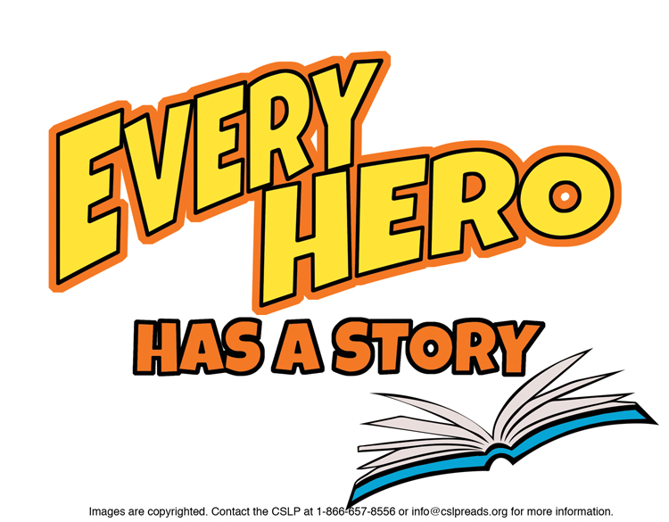

**Suggestions for 6th Grade**

**JUVENILE FICTION**

Alexander, Kwame.  ***The Crossover***.  Basketball prodigies face some unexpected challenges.  Told in verse.  
  
Balliett, Blue. ***Hold Fast*** & others by this author.  
Early solves the mystery of her missing father.

Berk, Josh**. *Strike Three, You’re Dead***.   
Lenny and friends investigate the death of a pitcher at a  
baseball game.  
  
Cody, Matthew. ***Will In Scarlet*** & others by this author.   
Will meets Robin Hood and joins the Merry Men.

Cushman, Karen.  ***Alchemy and Meggy Swann.***    
Meggy is brave in 16th century London.  
  
Erskine, Kathryn.  ***The Absolute Value of Mike*** & others by this author.  
Mike doesn’t “speak” calculus.

Flores-Galbis, Enrique. ***90 Miles to Havana.***In 1961, Julian leaves his family behind in Cuba.

Green, Tim. ***Football Genius*** & others by this author.   
Troy can predict upcoming football plays.

Hale, Shannon. ***Princess Academy***  & others by this author.   
At boarding school, Miri discovers an unknown talent.

Larson, Hope. ***A Wrinkle in Time: the Graphic Novel.***Meg Murray encounters some unearthly strangers.

Levine, Kristin.  ***The Lions of Little Rock*** & others by this author.  
Racial segregation threatens a friendship.

Naylor, Phyllis Reynolds*.* ***The Agony of Alice*** & others by this author.  
Alice is unhappy with her teacher until she gets to know her.

Ryan, Pam Muñoz***. Esperenza Rising*** & others by this author.   
During the 1930’s, Esperenza becomes a migrant worker.  
  
Vanderpool, Clare.  ***Navigating Early*** & others by this author.  
Two school outsiders seek adventure on the Appalachian Trail.

Weeks, Sarah. ***Pie*** & others by this author.   
Where did Aunt Polly hide her secret pie crust recipe?  
  
  
Yee, Lisa.  ***Stanford Wong Flunks Big Time*** & others by this author.  
Stanford’s bad grades land him in summer school.

**NON FICTION**

J 001.9 Murphy. ***Stuff that Scares Your Pants Off! The Science Scoop on More Than 30 Terrifying Phenomena!***Solid science and hilarious writing.

J 133.4 Schanzer. ***Witches! The Absolutely true tale of disaster in Salem***  & others by this author.  
A mysterious illness provokes a panic.

J 296.4 Hoffman. ***What You Will See Inside a Synagogue***.

J 327.12 Janeczko. ***Dark Game: True Spy Stories*** & others byPaul Janeszko.   
Tales of low- and high-tech espionage.

J 510 USING. ***Using Math to Solve a Crime*** *( Mathworks!)****.***Are your math skills good enough for detective work?

J 612.1 Newquist. ***The Book of Blood.***It all begins, and ends, with blood.

J 624 Caney. ***Steven Caney’s Ultimate Building Book*** & others.   
Build incredible structures from common objects.

J 636.7 TOP. ***Top Dog.***Describes more than 420 dog breeds.

J 726.2 Macaulay. ***Mosque*** & others by David Macaulay. Construction in 16th century Turkey.

J 796.357 Nelson. ***We Are the Ship: the story of Negro League*** ***Baseball*** & others by Kadir Nelson.

J 910.45 Hopkinson***. Titanic: Voices from the Disaster*** & others by Deborah Hopkinson.

J B Bernstein. ***Music Was It: Young Leonard Bernstein*** & others by Susan Goldman Rubin.   
A music prodigy becomes a famous composer and conductor.

J B Keller. ***The World at Her Fingertips: the story of Helen Keller*** & others by Joan Dash.

To find books in Talking Books format, search the Maryland State Library for the Blind & Physically Handicapped catalog at <http://webopac.klas.com/talkingbooks/md> or call 1-800-964-9209. MCPL also has audiobooks and Large Type Books. If this booklist is needed in another format, call 240-777-0959 or email [drcinfo@montgomerycountymd.gov](mailto:drcinfo@montgomerycountymd.gov).

[www.montgomerycountymd.gov/library](http://www.montgomerycountymd.gov/library)

MCPL logo