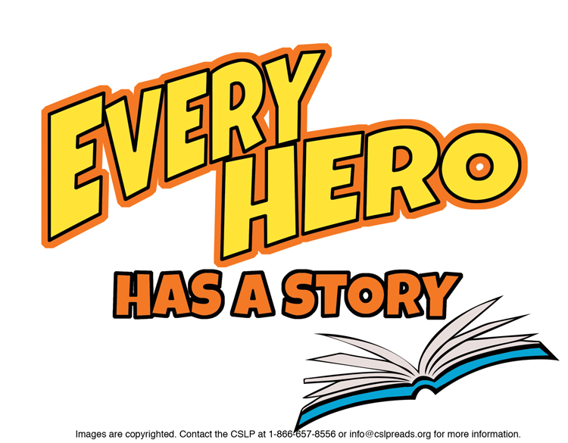

**Suggestions for 5th Grade**

**JUVENILE FICTION**

Armstrong, Kelley. ***Loki's Wolves***.   
This is the first title in the series.

Bell, Cece. ***El Deafo.*** (Graphic Novel)  
A new school and a hearing aid require superpowers.

Black, Holly. ***Doll Bones.***A sinister doll directs a quest.

Carlson-Voiles, Polly. ***Summer of the Wolves.***Nika and her brother raise a wolf cub.

Cooper, Susan. “***The Dark Is Rising” sequence.***

De Lint, Charles. ***Seven Wild Sisters***.   
The sisters are in the middle of a fairy feud.

Gaiman, Neil. ***The Graveyard Book***.   
A boy raised by ghosts as one of their own.

Graff, Lisa ***A Tangle of Knots.***Slightly magical orphan bakes your perfect cake.

Haddix, Margaret Peterson. ***Running Out of Time.***

Infinity Ring. ***A Mutiny in Time*** and other titles in the series.

Jones, Diana Wynne. ***Enchanted Glass.***Magical help needed against sinister creatures.

Kadohata, Cynthia. ***The Thing About Luck.***   
Summer turns out not as expected.

Kibuishi, Kazu. ***Amulet : The Stonekeeper.*** (Graphic Novel)  
Check out other *Amulet* titles, too!

Korman, Gordon. ***Swindle.***Griffin will do anything to get back what’s rightfully his.

Meloy, Colin. ***“Wildwood” books.***Prue goes into ‘The Wilderness’ to find her brother.

Montalbano, Andrea. ***Breakaway.***LJ’s suspended from the soccer team.

O'Hearn, Kate. ***The Flame of Olympus****.*   
Part of the *Pegasus* series.

Paulsen, Gary. ***“Lawn Boy” series.***A summer job turns into a mountain of cash.  
  
  
Rhodes, Jewell Parker. ***Ninth Ward***.   
Can Lanesha’s 2nd sight save her from the hurricane?

Urban, Linda. ***A Crooked Kind of Perfect.***   
Sometimes you work with what you have.

Williams-Garcia, Rita. ***P.S. Be Eleven*.**    
Sequel to *One Crazy Summer*.

**NON FICTION**

J 363.17 Kops. ***The Great Molasses Flood: Boston, 1919.***

J 398.2 Yolen. ***Mightier than the Sword: World Folktales for Strong Boys***.

J 540 Brown. ***Crazy Concoctions: A mad scientist’s guide to messy mixtures***.

J 569.6 Berger. ***The Skull in the Rock: How a Scientist, a Boy, and Google Earth Opened a New Window on Human Origins.***

J 590 Halls. ***Courageous Canine: and More True Stories of Animal Heroes.***

J 591 One. ***125 Stories of Amazing Animals.***

J 613.69 Champion. ***In an Emergency.***   
Survival tactics.

J 781.556 Stringer. ***When Stravinsky Met Nijinsky: Two Artists, Their Ballet, and One Extraordinary Riot.***

J 811 Hoberman. ***The Tree That time Built: A Celebration of Nature, Science, and Imagination***

J 817 Leno. ***How to be the Funniest Kid in the Whole Wide World (or just in your class).***

J 910.9 Ross. ***Into the Unknown: How Great Explorers Found Their Way by Land, Sea and Air.***

J 973.35 Lefkowitz. ***Bushnell’s Submarine: the best kept secret of the American Revolution.***

J 977.311 Murphy. ***The Great Fire.***Escape from the Great Chicago Fire.

J B Tubman. ***Harriet Tubman, Secret Agent: how daring slaves and free blacks spied for the Union during the Civil War.***

To find books in Talking Books format, search the Maryland State Library for the Blind & Physically Handicapped catalog at <http://webopac.klas.com/talkingbooks/md> or call 1-800-964-9209. MCPL also has audiobooks and Large Type Books. If this booklist is needed in another format, call 240-777-0959 or email [drcinfo@montgomerycountymd.gov](mailto:drcinfo@montgomerycountymd.gov).

[www.montgomerycountymd.gov/library](http://www.montgomerycountymd.gov/library)

MCPL logo