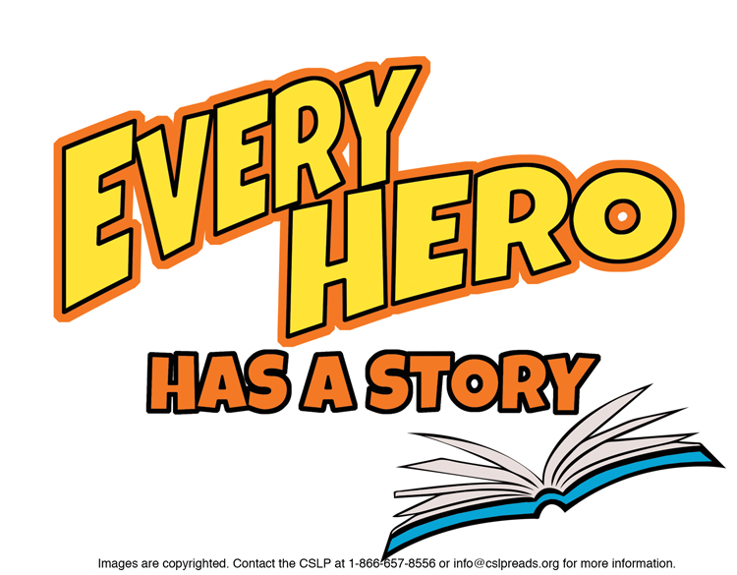

**Suggestions for 4th Grade**

**JUVENILE FICTION**

Aguirre, Jorge. ***Giants Beware****! (Graphic Novel)* Claudette embarks on a quest to defeat a giant.

Engle, Margarita. ***Mountain Dog.***Tony bonds with a search and rescue dog named Gabe.

Gaiman, Neil. ***Fortunately, the Milk.***A father encounters aliens and pirates on a trip to get milk.

Hale, Nathan. ***One Dead Spy.*** *(Graphic Novel)*Read another book in the *Hazardous Tales* series.

Healy, Christopher. ***The Hero's Guide to Saving Your Kingdom.***   
This is the first book in a series!

Hiranandani, Veera. ***The Whole Story of Half a Girl.***Sonia struggles to fit in after moving from private to public school.

Ignatow, Amy. ***Words of (Questionable) Wisdom from Lydia Goldblatt and Julie Graham-Chang.***Look for more titles in the *Popularity Papers* series.

Jennings, Patrick. ***Lucky Cap.***See other titles by this author!

Lin, Grace. ***The Year of the Dog.***Check out other books by Grace Lin about Pacy and her family.

McCall Smith, Alexander. ***The Great Cake Mystery.*** Read more books in the *Precious Ramotswe* series!

Naylor, Phyllis Reynolds. ***Emily’s Fortune*** . Emily and her turtle Rufus journey across the Wild West.

Peck, Richard. ***The Mouse with the Question Mark Tail.***Enjoy many more titles by this author.

Scieszka, Jon. ***SPHDZ 4 LIFE!*** Check out other books in the Spaceheadz series.

Shurtliff, Liesl. ***Rump: The True Story of Rumpelstiltskin.***Twelve year old Rump is endlessly teased about his name.

Weissman, Elissa Brent. ***Nerd Camp.***Also enjoy *Nerd Camp 2.0*, the sequel.

**NON FICTION**

J 031.02 ULT. ***Ultimate Weird But True 2.***For more interesting fact books, look at J 031.02.

J 362.4 Montalván. ***Tuesday Tucks Me In.***A day in the life of a service dog.

J 516.15 Adler. ***Triangles.***Read another book by this author.

J 567.9 Thimmesh. ***Scaly Spotted Feathered Frilled.***To learn more about dinosaurs, see J 567.9.

J 573.8 Jenkins. ***Eye to Eye: How Animals See the World.***Check out Jenkins’ *Just a Second***,** J 529 JEN, about time.

J 598.71 Roth. ***Parrots Over Puerto Rico.***Read lots of other great titles by this author!

J 633.7 Stewart. ***No Monkeys, No Chocolate.***How are monkeys and chocolate connected?

J 741.5 Nobleman. ***Bill the Boy Wonder: The Secret Co-Creator of Batman.***Read Nobleman’s *Boys of Steel*, J 741.5 NOB, about Superman.

J 745.5 OUT. ***Outdoor Crafts: Lots of Fun Things to Make and   
Do Outside.***Check out J 745.5 for more fun craft ideas.

J 791.068 Williams. ***Abandoned Amusement Parks.***Check out more books in the *Scary Places* series.

J 811 Singer. ***Follow Follow.***Reverse these fairy tale poems for more fun!

J 910 Jennings. ***Maps and Geography.***Read more Junior Genius Guides by Ken Jennings.

J B DiMaggio. ***The Streak: How Joe DiMaggio Became   
America's Hero.***The longest hitting streak in baseball history!

To find books in Talking Books format, search the Maryland State Library for the Blind & Physically Handicapped catalog at <http://webopac.klas.com/talkingbooks/md> or call 1-800-964-9209. MCPL also has audiobooks and Large Type Books. If this booklist is needed in another format, call 240-777-0959 or email [drcinfo@montgomerycountymd.gov](mailto:drcinfo@montgomerycountymd.gov).

[www.montgomerycountymd.gov/library](http://www.montgomerycountymd.gov/library)

MCPL logo