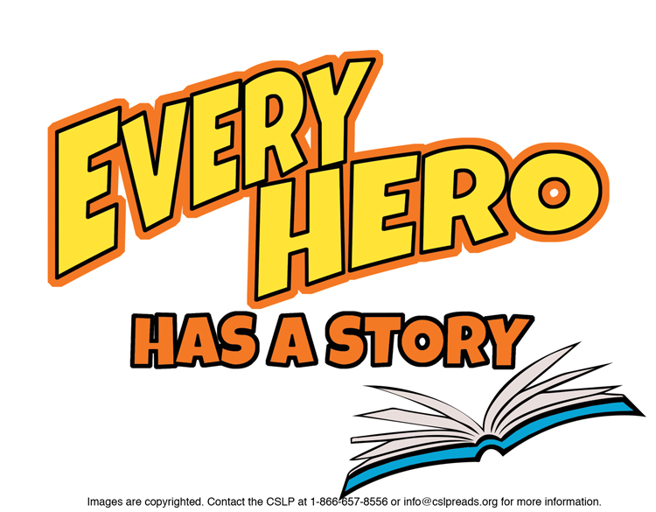

**Suggestions for 3rd Grade**

**EASY JUVENILE FICTION**

Barrows, Annie. ***“Ivy + Bean” books.***

Humorous adventures with an unlikely duo.

Clements, Andrew. ***“Jake Drake” books.***

Move over, Aesop-here comes Jake with fables of his own.

Kerrin, Jessica Scott. ***“Martin Bridge” books.***

Everything happens to Martin.

McDonald, Megan. ***“Judy Moody & Stink” books.***

Read their joint or individual escapades.

McKay, Hilary. ***“LuLu” books.***

She rescues animals.

Pennypacker, Sara.***“Clementine” books.***

It is never boring when you’re with Clementine.

Warner, Sally.  ***“Ellray Jakes” books***.

He’s a bully-buster, big brother and friend.  
  
**JUVENILE FICTION**

Abbott, Tony*. “****Goofballs” mystery books.***

With their disguises, they solve mysteries.

Alvarez, Julia. ***“Tía Lola” books***.

Tía Lola shakes things up for Miguel and Juanita.

Birney, Betty G. ***“Humphrey” books.***

The class pet listens in and tells all.

Bowe, Julie. ***“Friends for Keeps” books.***

*My Last Best Friend* begins the series.

Friedman, Laurie B*.* ***“Mallory” books.***

There’s never a dull moment for Mallory.

George, Jean Craighead. ***My Side of the Mountain;***

***On the Far Side of the Mountain; Frightful’s Mountain***

Read these tales of adventure and courage.

Kelly, Katy. ***“Melonhead” books.***

He juggles fun with staying out of trouble.

Mills, Claudia. ***“Mason Dixon” books.***

Why does Mason keep letting Brody talk him into things?  
  
Osborne, Mary Pope. ***“Tales from the Odyssey” books.***They’re the superheroes of ancient Greece!

Salisbury, Graham. ***“Calvin Coconut” books.***

Calvin’s misadventures in Hawaii.

**NON FICTION**

J 398.2 Amery. ***Usborne Stories from Around the World.***

International tales to enjoy. See others in J398.2.

J 595.7 Murawski. ***Ultimate Bugopedia.***

A National Geographic Kids book about amazing insects.

J 629.45 Goodman. ***How Do You Burp in Space? and other tips every space tourist should know.***

Explore more about space travel in J629.45, & planets in J523.

J 745.5 Big. ***The Big Book of Things to Make.***

100 activities and crafts. See others in J745.5.

J 793.7 Just. ***“Just Joking” National Geographic Kids books.***

Jokes and amazing facts. More joke books in J793.7.

J 796.334 Savage. ***“Top 25” Soccer Skills, Tips and Tricks.***

See “Top 25” books on gymnastics, baseball, basketball, hockey and football.

J 811 National. ***National Geographic Book of Animal Poetry.***

Enjoy these poems with photos & other poetry collections in J811.

J 920 Osborne. ***Heroes for all Times (“Magic Tree House Fact Tracker” book)***.   
Look for other *Magic Tree House Fact Tracker* books, too!

J 973.099 Rhatigan. ***White House Kids.***

Surprising stories. Also see *Presidential Pets,* J973.099 Moberg.

J 974.71 Rappaport. ***Lady Liberty .***

Learn more about the Statue of Liberty in J974.71.

J B Gandhi. ***Grandfather Gandhi.***

Read more books about this “peaceful warrior.”

J B Lee. ***Who Was Bruce Lee?*** *(Who was…Who is…)*

A master martial artist, author and actor. See Sally Ride, Steve Jobs, Rosa Parks and more.

To find books in Talking Books format, search the Maryland State Library for the Blind & Physically Handicapped catalog at <http://webopac.klas.com/talkingbooks/md> or call 1-800-964-9209. MCPL also has audiobooks and Large Type Books. If this booklist is needed in another format, call 240-777-0959 or email [drcinfo@montgomerycountymd.gov](mailto:drcinfo@montgomerycountymd.gov).

[www.montgomerycountymd.gov/library](http://www.montgomerycountymd.gov/library)

MCPL logo