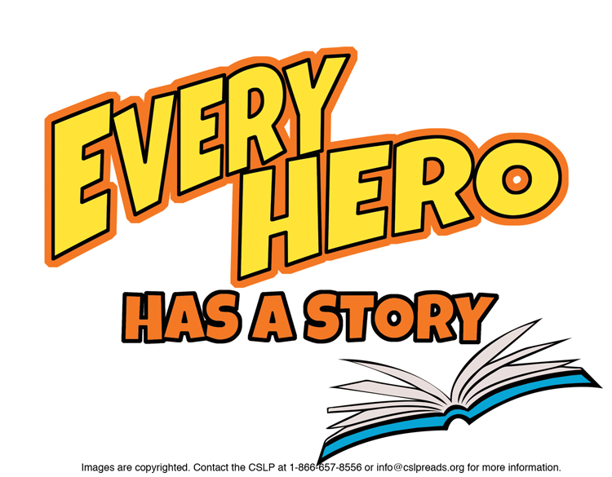

**Suggestions for 2nd Grade**

**Beginner**

Adler, David A. ***“Bones”*** mysteries.

Barss, Karen. ***“Martha Speaks”*** books.

Danziger, Paula. ***“A is for Amber”*** books.

Lin, Grace. ***“Ling & Ting”*** books.   
Identical twins that are not exactly the same.

**Easy Juvenile Fiction**

Adderson, Caroline**. *“Jasper John Dooley*”** books.  
  
English, Karen. ***“Nikki & Deja*”** books.  
  
Gerstein, Mordicai. ***How to Bicycle to the Moon to Plant Sunflowers: a Simple but Brilliant Plan in 24 Easy Steps.***  
Goto, Scott. ***The Perfect Sword.***Hicks, Betty. ***“Gym Shorts*”** books.  
  
Howe, James. ***“Houndsley & Catina”*** books.  
  
Jules, Jacqueline*.* ***“Zapato Power*”** books.   
Freddie Ramos and his super power shoes.  
  
Klise, Kate. ***Stand Straight, Ella Kate: The True Story of a   
Real Giant.***  
McCall Smith, Alexander. ***“Akimbo*”** books.  
  
Ryan, Pam Muñoz. ***Amelia and Eleanor Go for a Ride.***

**Juvenile Fiction**

Atinuke. ***“Anna Hibiscus*”** books.

Butler, Dori Hillestad. ***“Buddy Files*”** mysteries.   
A dog detective solves canine mysteries.

Mass, Wendy. ***Archie Takes Flight.***

Montgomery, Lewis B. ***“Milo & Jazz”*** mysteries.

**Graphic Novels**  
Baltazar, Art.  ***“Tiny Titans”*** books.   
World’s greatest tiny heroes.

Brown, Jeffrey. ***Jedi Academy***.   
Roan’s goofy comics and clippings of life at Jedi middle school.

Davila, Claudia. ***Luz Makes a Splash.***

Hatke, Ben. ***“Zita the Space Girl***” books.

Phelan, Matt. ***Bluffton: My Summers with Buster Keaton.***

Spires, Ashley.  ***“Binky Adventure”*** books.   
Can a house cat have an intergalactic journey?

**NON FICTION**

J 327.676 Deedy. ***14 Cows for America.***A Masai tribe gives a healing 9/11 gift.

J 363.37 Ollhoff. ***“Firefighters”*** and other Emergency Workers titles by Jim Ollhoff.   
 Exciting but sometimes dangerous jobs.

J 551.6 Cole. ***The Magic School Bus and the Climate Challenge.***

J 565 Barner. ***Dinosaurs Roar, Butterflies Soar!***  
J 592 Gravel. ***The Worm.***Humorous information about a disgusting creature.

J 599.88 Martin. ***Orangutans.***

J 609 McCarthy.  ***Pop! The Invention of Bubble Gum.***

J 636.7 Dennis. ***Nubs: the True Story of a Mutt, a Marine and a Miracle.***

J 641.86 DeVore**. *Ballerina Cookbook.***  
J B Baker. ***The Librarian of Basra.***

J B Chavez. ***Harvesting Hope.***

J B Chawla. ***Astronaut Kalpana Chawla: Reaching for the Stars.***

J B Reeves. ***Bad News for Outlaws: the Remarkable Life of Bass Reeves.***

J B Webster. ***Noah Webster and His Words.***

To find books in Talking Books format, search the Maryland State Library for the Blind & Physically Handicapped catalog at <http://webopac.klas.com/talkingbooks/md> or call 1-800-964-9209. MCPL also has audiobooks and Large Type Books. If this booklist is needed in another format, call 240-777-0959 or email [drcinfo@montgomerycountymd.gov](mailto:drcinfo@montgomerycountymd.gov).

[www.montgomerycountymd.gov/library](http://www.montgomerycountymd.gov/library)

MCPL logo