Gus and Inky's Rhyme Time   | Super Grover  In the Nick of Rhyme  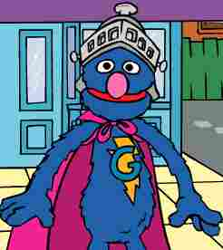 | Digby Mole  Rhyming Words  
Rhyme Time Matching 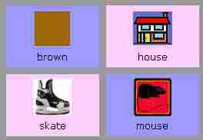 | Rhyme Time Concentration   | Word World 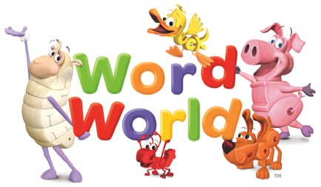
Super Why  Click on Wonder Red  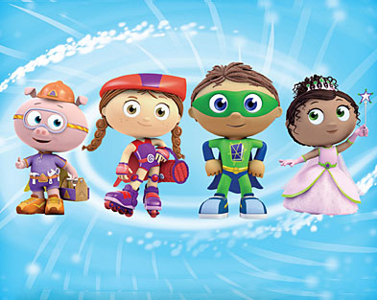 | Rhyming Rhino  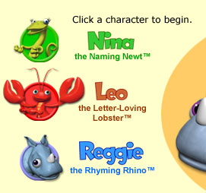
Rhyming

**Press “Control,” then click on the image to be taken to the website.

