ABC Watermelon  Type in the missing letter of the alphabet  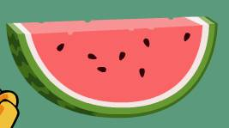 | Kangaroo Confusion  Match upper and lower case letters  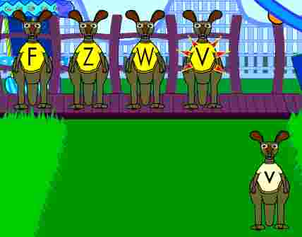 | Literacy Center  Letter, color, shape, and number activities  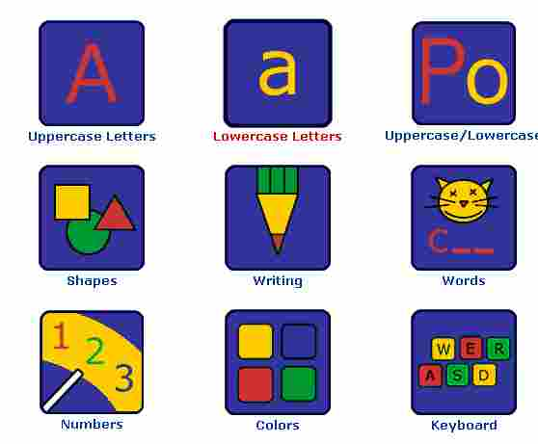
Starfall Alphabet  Learn about the alphabet  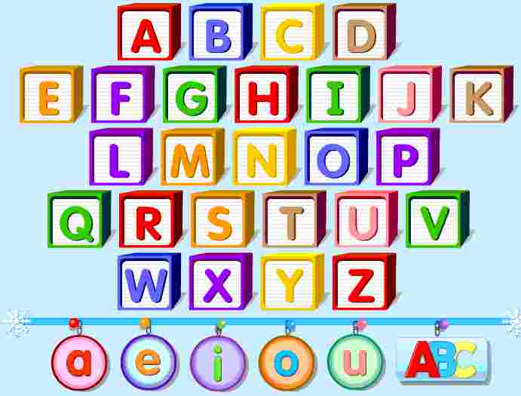 | Super Why  Click on Alpha Pig to paint by letter  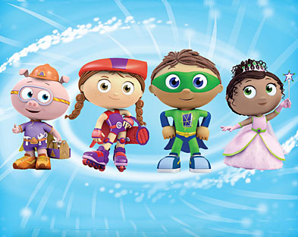 | Clifford’s Letter Sort  Sort the words by looking at the beginning letter  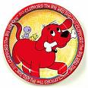
Whack-A-Mole  Whack the moles in ABC order  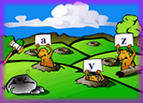 | Spring Bee  Help the bees collect the letters in ABC order  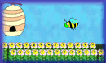 | Alphabet Books  Put the books in ABC order  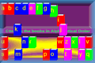
Letter Fire  Click on the red and blue letters to match  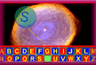 | Alphabet Antics  Click on the matching letter  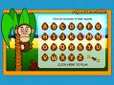 | Cup Stacking  Type in the matching letter of the alphabet on the cups  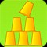
Letter ID

