**Press “Control,” then click on the image to be taken to the website.
Patterns
Checkout Cookie  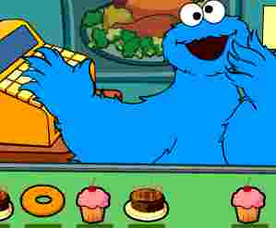 | Pattern Beads  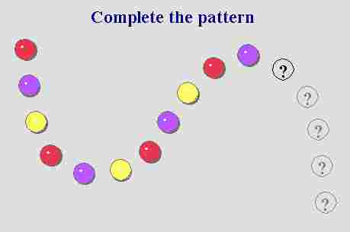 | Oscar’s Trash Collection  
Bert’s Bottlecaps   | Zoe’s Pet Shelter   | Shape Patterns  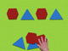

Counting
Elmo’s Chicken Dance  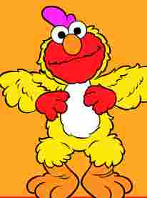 | Count it Out   | Counting On  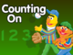
Counting with Big Bird  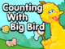 | Fix the 100s Chart  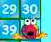 | Count to 100  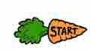

Shapes
Attribute Game  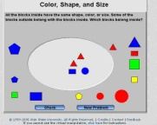 | Name the Shapes   | Tangram Puzzles  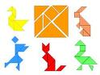
Colors and Shapes   | Big Bird’s Shapes   | Find the Shapes  