Conclusion
Through the hard work of building service staff
- Parents can trust that a safe, healthy facility environment is being provided for their children;
- Teachers and other staff can comfortably focus their attention on students;
- Students learn.

THANK YOU

School Name Here
Elementary School
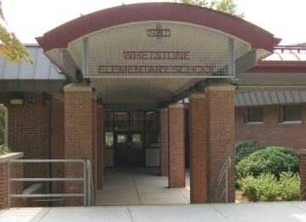
Building Service Staff
Services and Procedures

Please assist us in making everything run smoothly for the upcoming year
John Doe, Building Service Manager
School Name
000-000-0000 Main Office
000-000-0000 Building Service Office

BSM Email address (goes here)
Our Mission

The Building Service Staff is here to provide a healthy, safe and clean environment for all students and staff at (school name)

Building Use Hours of Operation
to ensure Safety and Security

In order to ensure the safety and security of (School Name), please adhere to the following schedule and Procedures
Monday through Friday
  - Opens At 6:00 a.m.
  - Closes at 10:00 p.m.
Please be sure to make building service staff are aware of your presence after 7:00 p.m.
Weekend Use
Staff who would like access to the building must have prior approval from the following:

Elementary School
  - Principal – Victoria Casey
  - Assistant Principal – Antonio Scott
  - Building Service Manager – Edward Turnbow
Sign-In/ Out procedures must be followed at all times using the designated entrance and exit.
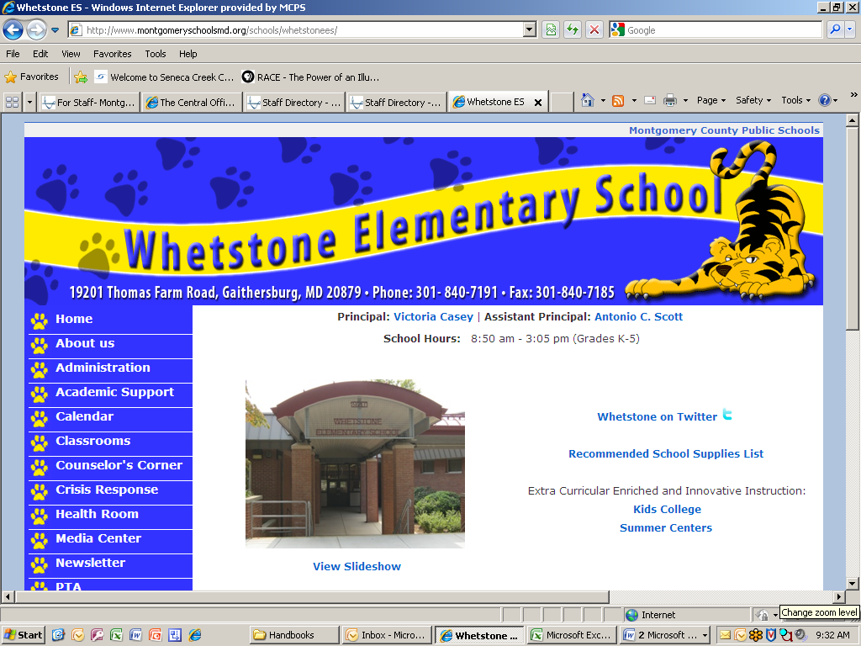

Work Request Procedures
All requests for building service assistance should be directed to the building service manager as follows.
- Submit work request to the building service manager through email including requests regarding heating and air conditioning
- If you have an immediate need please contact the main office and they will direct your request to the building service manager
- Do not stop building services workers in the hall with requests. Daily tasks are assigned to them and daily schedules are in place. It is vital that we respect their work schedules and go through the proper procedures for requests
Your satisfaction is important to the building service staff. Please email us feedback about the timeliness and quality of our services.

Building Service Staff
John Doe
Building Service Manager
Email Address

The building Service manager is responsible for the management of the building service staff determining
Work assignments and schedules for building service staff

John Doe
Building Service Assistant Manager
Email Address

The building service assistant manager as directed by the building manager is responsible for management of the building service staff in the evenings; determining work assignments, schedules, grounds care, and to ensure that all mechanical systems are operating properly.

Day Shift:
Name
Name
Name
Name

Building Service Staff xContinue

Evening Shift:
Name
Name
Name
Name
Name
Name
Name
Name
Name
Name
Name
Name
Name
Name
Name

ICB

Classroom Procedures

Each classroom has been supplied with two recycle bins, one for paper items and on for cans/bottles. Please make an effort to encourage students to use both

Please have students place their chairs on top of their desk during your last period of the school day. This helps night staff perform their duties in a timely manner so that classrooms are ready for the morning classes.

Administration/business manager will be notified if chairs are left down on a continual basis. It is important that we all make efforts to ensure the cleanliness of our learning environment.



Schools Events

Please see business manager/building service manager (HS) Principal or Assistant Principal/ Building Service Manager (ES/MS) for event request and set up instructions.

Event requests and set up needs must be submitted at least 2 weeks prior to event

Special Request

All special requests should be made via email or request form to the building service manager

Shared Computer Files
The shared computer files contain building service files that can be accessed by all staff.

Includes the following:
- Filter Maintenance Schedule
- Building Layout and Cleaning Schedule
- Building Service Updates
- Energy Management Information
- Event request Forms
- Maintenance Request Forms

