**Secondary ESOL IS Job Jar**

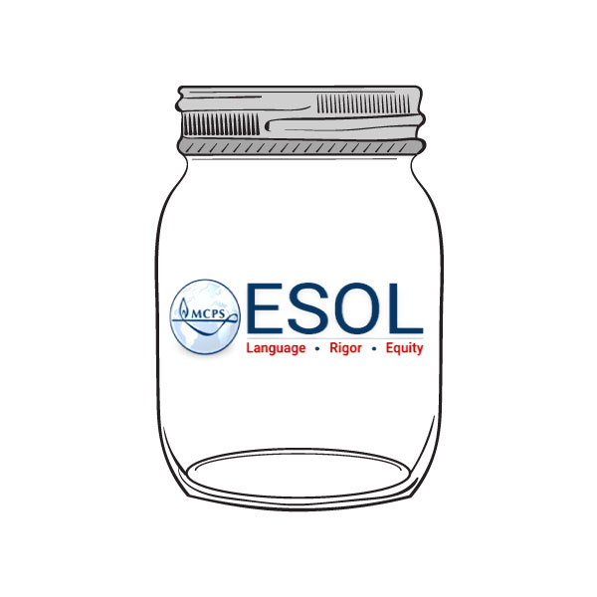

|  |  |
| --- | --- |
| **Brent** | **Sandy** |
| * Middle School and High School Support * Middle and High School Language Progress Checks * Lead Middle School CS Meetings * HS ESOL 5 Curriculum Development * Social Studies Team Support | * Elementary (METS sites only), Middle School, and High School Support * Online Design and Development of eLearning Courses * Website Design and Development * MS ESOL 1 and 2 Curriculum Development * METS Programming Support |
| **Rosemary** | **Cindy** |
| **METS Programming**   * Placement, Transportation, and Data Collection * Assessment Plan * Lead METS Articulation Meetings * Curriculum Implementation and Related Professional Learning * Math Team Support | * Middle School and High School Support * Middle and High School Language Progress Checks * Lead High School ESOL RT Meetings * HS ESOL 4 Curriculum Development * Science Team Support |

**ALL of Us**

* EL Professional Learning

Department and/or Schoolwide

* EL Data Teams
* Supporting New and Veteran EL Teachers w/Instruction & Assessment
* WIDA Testing (ACCESS, Screener, and Model)
* ESOL Paperwork/ETAC Support
* Be Available!